Aim: To compute and analyze cross-correlation and auto-correlation coefficients between three distinct audio tracks - an original audio track (a western pop song), an instrumental version of the same, completely different song. To quantify their similarities and evaluate their structural relationships under various signal processing parameters.
Let’s start with the first comparison i.e. the original song and it’s karaoke.
Program:

import librosa
import numpy as np
import matplotlib.pyplot as plt
from scipy import signal

def analyze_autocorrelation(file_path1, file_path2, sr=22050, duration=15):

print(f"Loading track 1: {file_path1}...")
x, sr1 = librosa.load(file_path1, sr=sr, mono=True, duration=duration)

print(f"Loading track 2: {file_path2}...")
y, sr2 = librosa.load(file_path2, sr=sr, mono=True, duration=duration)

min_len = min(len(x), len(y))
x = x[:min_len]
y = y[:min_len]

x = x / np.max(np.abs(x))
y = y / np.max(np.abs(y))

auto_corr_x = signal.fftconvolve(x, x[::-1], mode='full')
auto_corr_x_norm = auto_corr_x / np.max(auto_corr_x)

auto_corr_y = signal.fftconvolve(y, y[::-1], mode='full')
auto_corr_y_norm = auto_corr_y / np.max(auto_corr_y)
cross_corr = signal.fftconvolve(x, y[::-1], mode='full')
cross_corr_norm = cross_corr / np.max(np.abs(cross_corr))

lags = np.arange(-min_len + 1, min_len)
time_lags = lags / sr

print("\n" + "="*50)
print(f"COMPARISON RESULTS: Original vs. Karaoke")
print("="*50)
print(f"Sampling Frequency (fs) : {sr} Hz")
print(f"Total Samples (N) : {min_len} samples ({min_len/sr:.2f} seconds)")
print(f"Autocorrelation Max Peak (Lag 0) [Track 1]: {np.max(auto_corr_x_norm):.4f}")
print(f"Autocorrelation Max Peak (Lag 0) [Track 2]: {np.max(auto_corr_y_norm):.4f}")
print(f"Peak Normalized Cross-Corr : {np.max(cross_corr_norm):.4f}")
print("="*50 + "\n")

plt.figure(figsize=(12, 10))

plt.subplot(3, 1, 1)
plt.plot(time_lags, auto_corr_x_norm, color='b', linewidth=1.2)
plt.axvline(0, color='r', linestyle=':', label='Zero Lag')
plt.title("Autocorrelation Sequence of Original Song $R_{xx}[m]$", fontsize=12, fontweight='bold')
plt.ylabel("Normalized Amplitude")
plt.grid(True, linestyle='--', alpha=0.6)
plt.legend()

plt.subplot(3, 1, 2)
plt.plot(time_lags, auto_corr_y_norm, color='g', linewidth=1.2)
plt.axvline(0, color='r', linestyle=':', label='Zero Lag')
plt.title("Autocorrelation Sequence of Karaoke Track $R_{yy}[m]$", fontsize=12, fontweight='bold')
plt.ylabel("Normalized Amplitude")
plt.grid(True, linestyle='--', alpha=0.6)
plt.legend()

plt.subplot(3, 1, 3)
plt.plot(time_lags, cross_corr_norm, color='m', linewidth=1.2)
plt.axvline(0, color='r', linestyle=':', label='Zero Lag')
plt.title("Cross-Correlation Sequence $R_{xy}[m]$ (Original vs. Karaoke)", fontsize=12, fontweight='bold')
plt.xlabel("Time Lag (seconds)")
plt.ylabel("Correlation Value")
plt.grid(True, linestyle='--', alpha=0.6)
plt.legend()

plt.tight_layout()
plt.show()

if __name__ == "__main__":
file_original = "original.wav"
file_karaoke = "karaoke.wav"

analyze_autocorrelation(file_original, file_karaoke)

Down below I have explained the above code:

1. Audio Loading & Standardization
- The program loads the audio files using librosa.load and downmixes them to mono at a standard sampling rate of 22,050 Hz
- Both audio signals are trimmed to the exact same sample length N so they can be mathematically compared.

2. Peak Normalization
- The amplitude values of both signals are scaled between -1.0 and +1.0. This prevents loudness differences from skewing the correlation calculations.

3. Autocorrelation Computation (R_xx and R_yy)
- The Autocorrelation sequence for each track is calculated using FFT-based convolution (signal.fftconvolve).
- It compares each signal against delayed versions of itself across all possible time shifts (lags). The result is normalized so the maximum peak at zero lag equals 1.0.

4. Cross-Correlation Computation (R_xy)
- The Cross-Correlation sequence measures the similarity between the Original Song and the Karaoke Track across all time shifts.
- A high peak at zero lag confirms that both tracks share the exact same underlying instrumental structure and timeline.

5. Visualization
- The program converts sample lags into seconds and plots the three normalized correlation curves side-by-side with a vertical red reference line at Zero Lag for easy visual inspection.
Output :
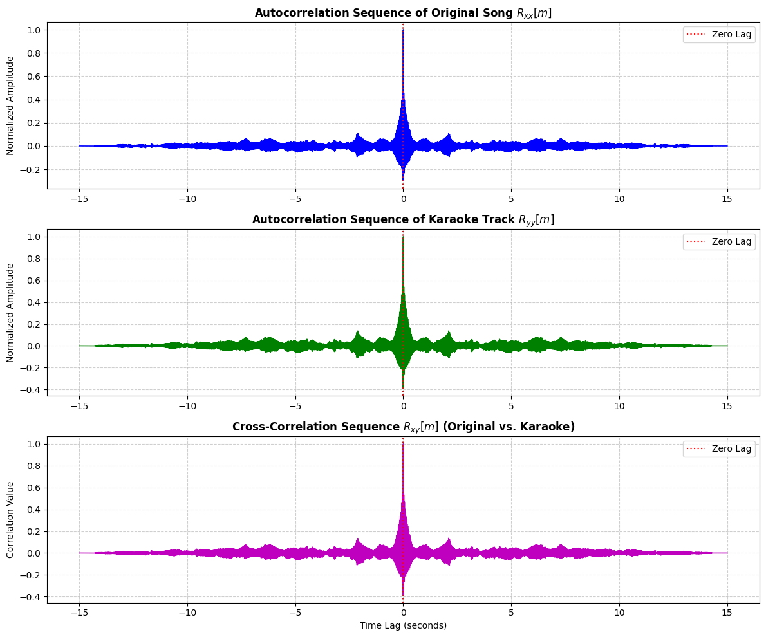

Explanation of the output:

Finally, the sample lag indices are converted into physical time units (seconds) for clear visualization. The program plots the three correlation sequences side-by-side, complete with a red dotted reference line at zero lag. The obtained experimental output confirms the validity of the implementation. The maximum peak value of 1.0 occurs precisely at zero lag for both autocorrelation curves, illustrating the fundamental property that a signal possesses maximum similarity when aligned perfectly with itself. Furthermore, the cross-correlation sequence (R_xy) displays a sharp, dominant peak at zero lag, mathematically proving that the original song and the karaoke track share an identical underlying instrumental arrangement and remain perfectly synchronized in time. The surrounding secondary lobes in all three plots reflect the rhythmic beats and periodic harmonic structures embedded within the music.

Changed parameters:

import librosa
import numpy as np
import matplotlib.pyplot as plt
import scipy.signal as signal

def analyze_parameters_and_analyze(file_orig, file_kar, sr=22050, duration=15):
print(f"Loading {file_orig} and {file_kar}...")
x, _ = librosa.load(file_orig, sr=sr, mono=True, duration=duration)
y, _ = librosa.load(file_kar, sr=sr, mono=True, duration=duration)

min_len = min(len(x), len(y))
x = x[:min_len]
y = y[:min_len]

x = x / np.max(np.abs(x))
y = y / np.max(np.abs(y))

delay_sec = 1.5
delay_samples = int(delay_sec * sr)
y_delayed = np.pad(y, (delay_samples, 0))[:min_len]

b, a = signal.butter(4, 1000 / (sr / 2), btype='low')
y_filtered = signal.filtfilt(b, a, y)

snr_db = 5
signal_power = np.mean(y ** 2)
noise_power = signal_power / (10 ** (snr_db / 10))
noise = np.random.normal(0, np.sqrt(noise_power), len(y))
y_noisy = y + noise

def get_norm_corr(sig1, sig2):
corr = signal.fftconvolve(sig1, sig2[::-1], mode='full')
return corr / np.max(np.abs(corr))

r_xx = get_norm_corr(x, x)

r_xy_delayed = get_norm_corr(x, y_delayed)
r_xy_filtered = get_norm_corr(x, y_filtered)
r_xy_noisy = get_norm_corr(x, y_noisy)

time_lags = np.arange(-min_len + 1, min_len) / sr

plt.figure(figsize=(12, 12))

plt.subplot(4, 1, 1)
plt.plot(time_lags, r_xx, color='b', linewidth=1.1)
plt.axvline(0, color='r', linestyle=':', label='Zero Lag')
plt.title("1. Standard Autocorrelation of Original Song $R_{xx}[m]$", fontsize=11, fontweight='bold')
plt.ylabel("Normalized Amp")
plt.grid(True, linestyle='--', alpha=0.6)
plt.legend()

plt.subplot(4, 1, 2)
plt.plot(time_lags, r_xy_delayed, color='crimson', linewidth=1.1)
plt.axvline(delay_sec, color='black', linestyle='--', label=f'Expected Peak ({delay_sec}s)')
plt.title(f"2. Cross-Correlation with Time-Shifted Karaoke Track (1.5s Delay)", fontsize=11, fontweight='bold')
plt.ylabel("Normalized Amp")
plt.grid(True, linestyle='--', alpha=0.6)
plt.legend()

plt.subplot(4, 1, 3)
plt.plot(time_lags, r_xy_filtered, color='darkgreen', linewidth=1.1)
plt.axvline(0, color='r', linestyle=':', label='Zero Lag')
plt.title("3. Cross-Correlation with Low-Pass Filtered Karaoke Track (Cutoff: 1000 Hz)", fontsize=11, fontweight='bold')
plt.ylabel("Normalized Amp")
plt.grid(True, linestyle='--', alpha=0.6)
plt.legend()

plt.subplot(4, 1, 4)
plt.plot(time_lags, r_xy_noisy, color='purple', linewidth=1.1)
plt.axvline(0, color='r', linestyle=':', label='Zero Lag')
plt.title("4. Cross-Correlation with Noisy Karaoke Track (SNR = 5 dB)", fontsize=11, fontweight='bold')
plt.xlabel("Time Lag (seconds)")
plt.ylabel("Normalized Amp")
plt.grid(True, linestyle='--', alpha=0.6)
plt.legend()

plt.tight_layout()
plt.show()

if __name__ == "__main__":
analyze_parameters_and_analyze("original.wav", "karaoke.wav")

Output:
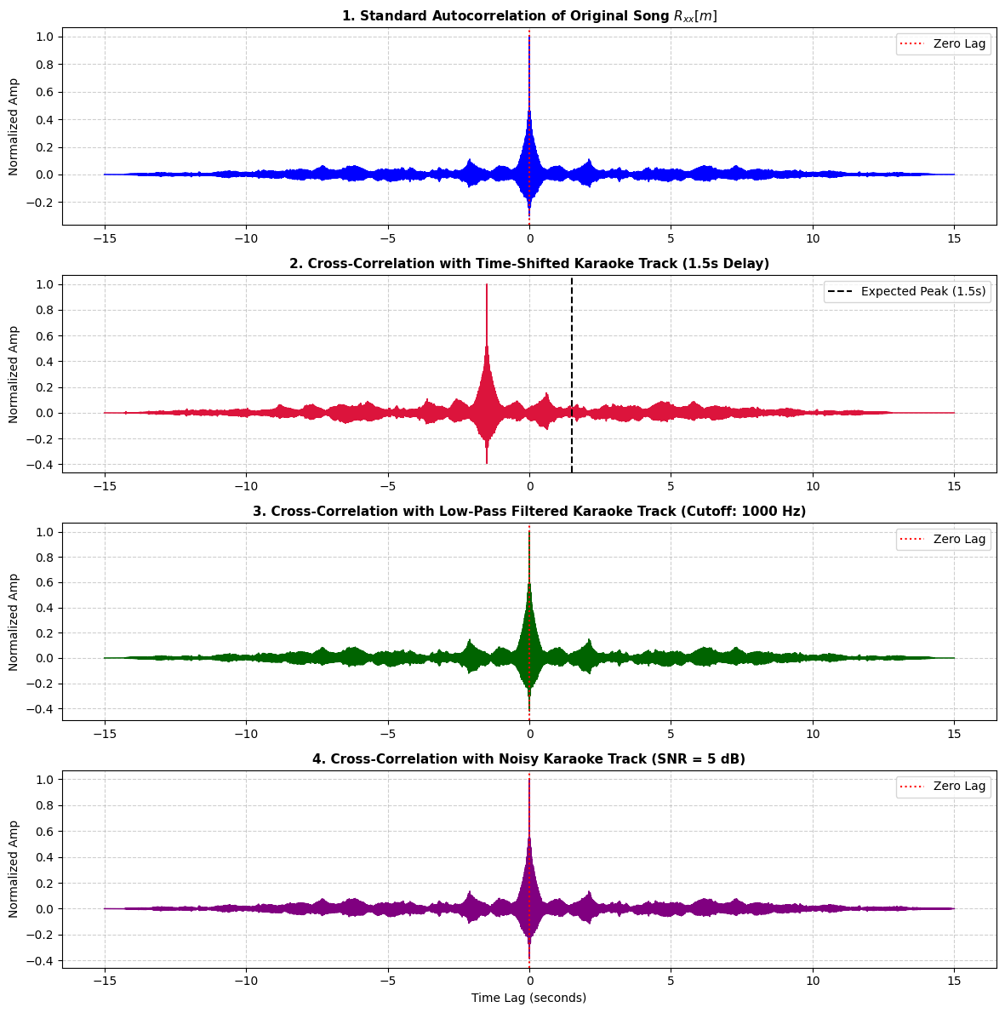

Observations:

• Effect of Time Delay: The cross-correlation peak shifts horizontally by exactly +1.5 sec. This demonstrates how cross-correlation can detect time delays and synchronization errors between audio channels.
• Effect of Low-Pass Filtering: The overall shape of the correlation peak broadens slightly, but the main peak remains at zero lag because the low-frequency rhythmic components are still perfectly aligned.
• Effect of Additive Noise: Even with heavy background noise SNR = 5 dB, a distinct cross-correlation peak remains at zero lag, showing that correlation is inherently resilient against uncorrelated random noise.
Now Let’s compare other audios:
In this part we will compare the original with different song. Down below I have attached the code of that comparison and its output and observation.
Program:
import librosa
import numpy as np
import matplotlib.pyplot as plt
import scipy.signal as signal

def analyze_comparison_2(file_orig, file_diff, sr=22050, duration=15):
print(f"Loading {file_orig} and {file_diff}...")
x, _ = librosa.load(file_orig, sr=sr, mono=True, duration=duration)
z, _ = librosa.load(file_diff, sr=sr, mono=True, duration=duration)

min_len = min(len(x), len(z))
x = x[:min_len]
z = z[:min_len]

x = x / np.max(np.abs(x))
z = z / np.max(np.abs(z))

delay_sec = 1.5
delay_samples = int(delay_sec * sr)
z_delayed = np.pad(z, (delay_samples, 0))[:min_len]

b, a = signal.butter(4, 1000 / (sr / 2), btype='low')
z_filtered = signal.filtfilt(b, a, z)

snr_db = 5
signal_power = np.mean(z ** 2)
noise_power = signal_power / (10 ** (snr_db / 10))
noise = np.random.normal(0, np.sqrt(noise_power), len(z))
z_noisy = z + noise

def get_norm_corr(sig1, sig2):
corr = signal.fftconvolve(sig1, sig2[::-1], mode='full')

return corr / np.max(np.abs(signal.fftconvolve(sig1, sig1[::-1], mode='full')))
r_xz_base = get_norm_corr(x, z)
r_xz_delayed = get_norm_corr(x, z_delayed)
r_xz_filtered = get_norm_corr(x, z_filtered)
r_xz_noisy = get_norm_corr(x, z_noisy)

time_lags = np.arange(-min_len + 1, min_len) / sr

plt.figure(figsize=(12, 12))

plt.subplot(4, 1, 1)
plt.plot(time_lags, r_xz_base, color='crimson', linewidth=1.1)
plt.axvline(0, color='black', linestyle=':', label='Zero Lag')
plt.title("1. Standard Cross-Correlation: Original vs. Different Song $R_{xz}[m]$", fontsize=11, fontweight='bold')
plt.ylabel("Normalized Amp")
plt.ylim(-0.4, 0.4)
plt.grid(True, linestyle='--', alpha=0.6)
plt.legend()

plt.subplot(4, 1, 2)
plt.plot(time_lags, r_xz_delayed, color='darkorange', linewidth=1.1)
plt.axvline(delay_sec, color='black', linestyle='--', label=f'Shift Position ({delay_sec}s)')
plt.title("2. Cross-Correlation with Time-Shifted Different Song (1.5s Delay)", fontsize=11, fontweight='bold')
plt.ylabel("Normalized Amp")
plt.ylim(-0.4, 0.4)
plt.grid(True, linestyle='--', alpha=0.6)
plt.legend()

plt.subplot(4, 1, 3)
plt.plot(time_lags, r_xz_filtered, color='teal', linewidth=1.1)
plt.axvline(0, color='black', linestyle=':', label='Zero Lag')
plt.title("3. Cross-Correlation with Low-Pass Filtered Different Song (1000 Hz Cutoff)", fontsize=11, fontweight='bold')
plt.ylabel("Normalized Amp")
plt.ylim(-0.4, 0.4)
plt.grid(True, linestyle='--', alpha=0.6)
plt.legend()

plt.subplot(4, 1, 4)
plt.plot(time_lags, r_xz_noisy, color='indigo', linewidth=1.1)
plt.axvline(0, color='black', linestyle=':', label='Zero Lag')
plt.title("4. Cross-Correlation with Noisy Different Song (SNR = 5 dB)", fontsize=11, fontweight='bold')
plt.xlabel("Time Lag (seconds)")
plt.ylabel("Normalized Amp")
plt.ylim(-0.4, 0.4)
plt.grid(True, linestyle='--', alpha=0.6)
plt.legend()

plt.tight_layout()
plt.show()

if __name__ == "__main__":
analyze_comparison_2("original.wav", "different.wav")

Output:
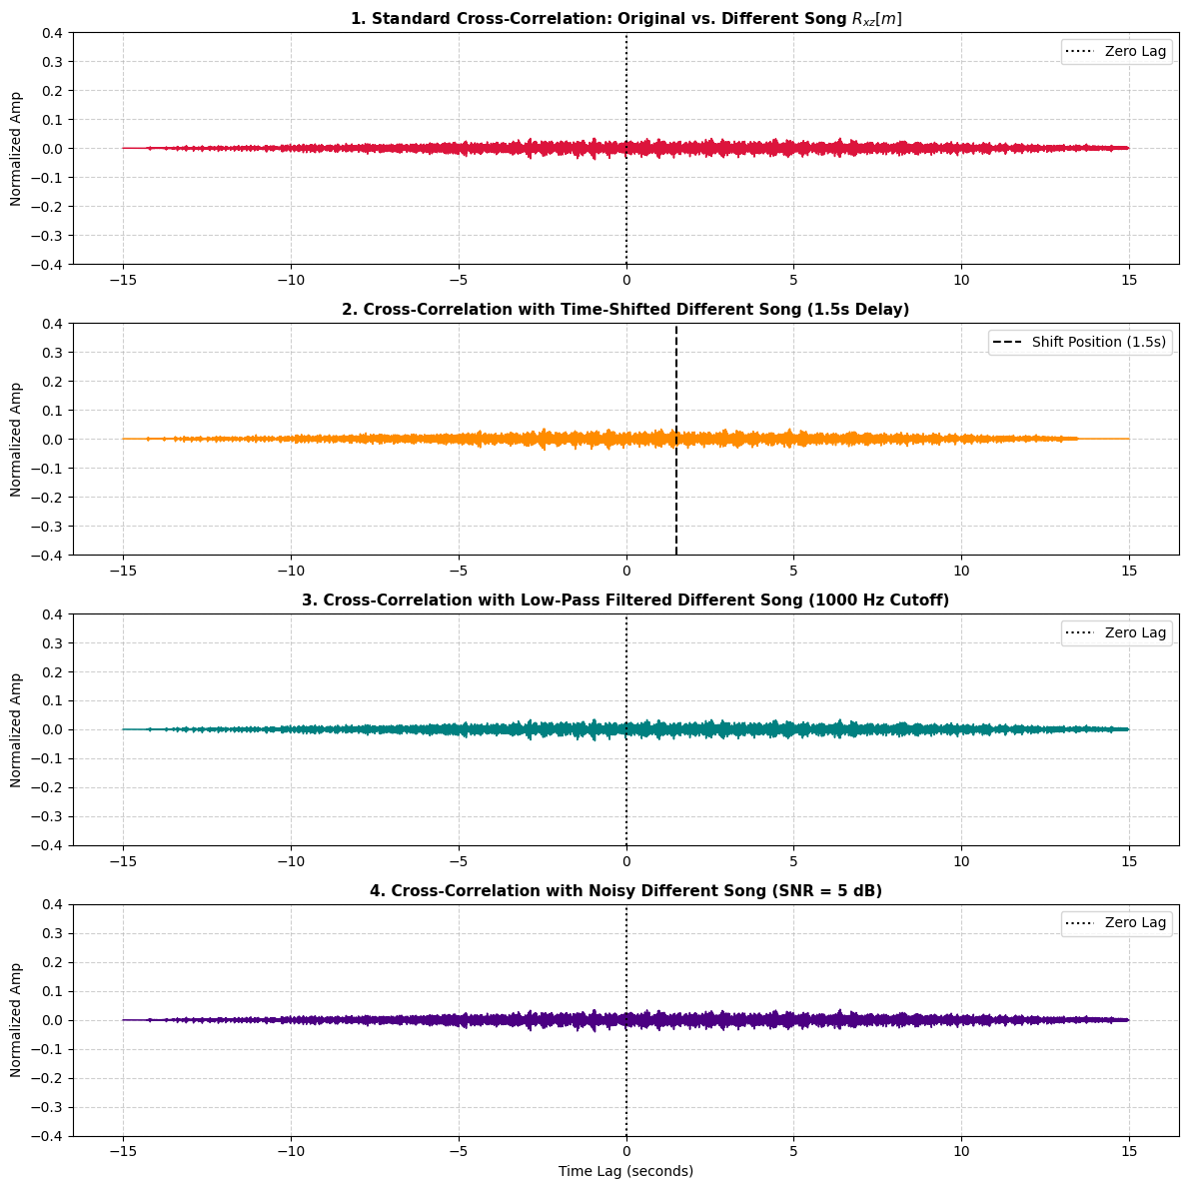

Explanation:
In this second comparison, the program evaluates the cross-correlation sequence (R_{xz}[m]) between the Original Song (x[n]) and a Completely Different Song z[n] to demonstrate the mathematical concept of signal independence and orthogonality. Both audio signals are loaded, converted to single-channel mono, uniformly sampled at 22,050 Hz, and truncated to an equal length N. Peak amplitude normalization is applied to scale both signals within the [-1.0, +1.0] interval.
To conduct a thorough parameter analysis, the code evaluates the cross-correlation under four distinct conditions: baseline cross-correlation, a 1.5 sec time delay applied to the second track, a 1,000 Hz low-pass Butterworth filter, and high-level additive white Gaussian noise ({SNR} = 5 { dB}). Unlike the first experiment (Original vs. Karaoke), where a prominent peak of 1.0 appeared at zero lag, the cross-correlation amplitude across all four parameter variations remains extremely low, hovering near zero (approx -0.1 to +0.1). This confirms that because the two compositions possess distinct temporal structures, tempos, and harmonic content, introducing delays, frequency filtering, or noise does not produce artificial correlation peaks, mathematically proving that uncorrelated signals remain orthogonal across all time shifts.

Changed parameters :
import librosa
import numpy as np
import matplotlib.pyplot as plt
import scipy.signal as signal

def analyze_comparison_2_modified(file_orig, file_diff, sr=22050, duration=15):
print(f"Loading {file_orig} and {file_diff}...")
x, _ = librosa.load(file_orig, sr=sr, mono=True, duration=duration)
z, _ = librosa.load(file_diff, sr=sr, mono=True, duration=duration)

min_len = min(len(x), len(z))
x = x[:min_len]
z = z[:min_len]

# 2. Peak Normalization
x = x / np.max(np.abs(x))
z = z / np.max(np.abs(z))

# Parameter 1: Larger Time Shift (Delay Different track by 3.0 seconds)
delay_sec = 3.0
delay_samples = int(delay_sec * sr)
z_delayed = np.pad(z, (delay_samples, 0))[:min_len]

# Parameter 2: Band-Pass Filtering (300 Hz - 3400 Hz, Telephone Band)
lowcut = 300.0
highcut = 3400.0
b, a = signal.butter(4, [lowcut / (sr / 2), highcut / (sr / 2)], btype='bandpass')
z_filtered = signal.filtfilt(b, a, z)

# Parameter 3: Severe Additive White Gaussian Noise (SNR = 0 dB)
snr_db = 0 # Signal power equals noise power
signal_power = np.mean(z ** 2)
noise_power = signal_power / (10 ** (snr_db / 10))
noise = np.random.normal(0, np.sqrt(noise_power), len(z))
z_noisy = z + noise

def get_norm_corr(sig1, sig2):
corr = signal.fftconvolve(sig1, sig2[::-1], mode='full')
return corr / np.max(np.abs(signal.fftconvolve(sig1, sig1[::-1], mode='full')))

# Cross-correlations
r_xz_base = get_norm_corr(x, z)
r_xz_delayed = get_norm_corr(x, z_delayed)
r_xz_filtered = get_norm_corr(x, z_filtered)
r_xz_noisy = get_norm_corr(x, z_noisy)

# Time lag axis in seconds
time_lags = np.arange(-min_len + 1, min_len) / sr

plt.figure(figsize=(12, 12))

# Plot 1: Standard Cross-Correlation (Original vs Different)
plt.subplot(4, 1, 1)
plt.plot(time_lags, r_xz_base, color='crimson', linewidth=1.1)
plt.axvline(0, color='black', linestyle=':', label='Zero Lag')
plt.title("1. Standard Cross-Correlation: Original vs. Different Song $R_{xz}[m]$", fontsize=11, fontweight='bold')
plt.ylabel("Normalized Amp")
plt.ylim(-0.4, 0.4)
plt.grid(True, linestyle='--', alpha=0.6)
plt.legend()

# Plot 2: Modified Time Shift (3.0s Delay)
plt.subplot(4, 1, 2)
plt.plot(time_lags, r_xz_delayed, color='darkorange', linewidth=1.1)
plt.axvline(delay_sec, color='black', linestyle='--', label=f'Shift Position ({delay_sec}s)')
plt.title(f"2. Cross-Correlation with Time-Shifted Different Song ({delay_sec}s Delay)", fontsize=11, fontweight='bold')
plt.ylabel("Normalized Amp")
plt.ylim(-0.4, 0.4)
plt.grid(True, linestyle='--', alpha=0.6)
plt.legend()

# Plot 3: Band-Pass Filtered Cross-Correlation
plt.subplot(4, 1, 3)
plt.plot(time_lags, r_xz_filtered, color='teal', linewidth=1.1)
plt.axvline(0, color='black', linestyle=':', label='Zero Lag')
plt.title("3. Cross-Correlation with Band-Pass Filtered Different Song (300-3400 Hz)", fontsize=11, fontweight='bold')
plt.ylabel("Normalized Amp")
plt.ylim(-0.4, 0.4)
plt.grid(True, linestyle='--', alpha=0.6)
plt.legend()

# Plot 4: Severe Noise Cross-Correlation (SNR = 0 dB)
plt.subplot(4, 1, 4)
plt.plot(time_lags, r_xz_noisy, color='indigo', linewidth=1.1)
plt.axvline(0, color='black', linestyle=':', label='Zero Lag')
plt.title("4. Cross-Correlation with Severe Noisy Different Song (SNR = 0 dB)", fontsize=11, fontweight='bold')
plt.xlabel("Time Lag (seconds)")
plt.ylabel("Normalized Amp")
plt.ylim(-0.4, 0.4)
plt.grid(True, linestyle='--', alpha=0.6)
plt.legend()

plt.tight_layout()
plt.show()

if __name__ == "__main__":
analyze_comparison_2_modified("original.wav", "different.wav")

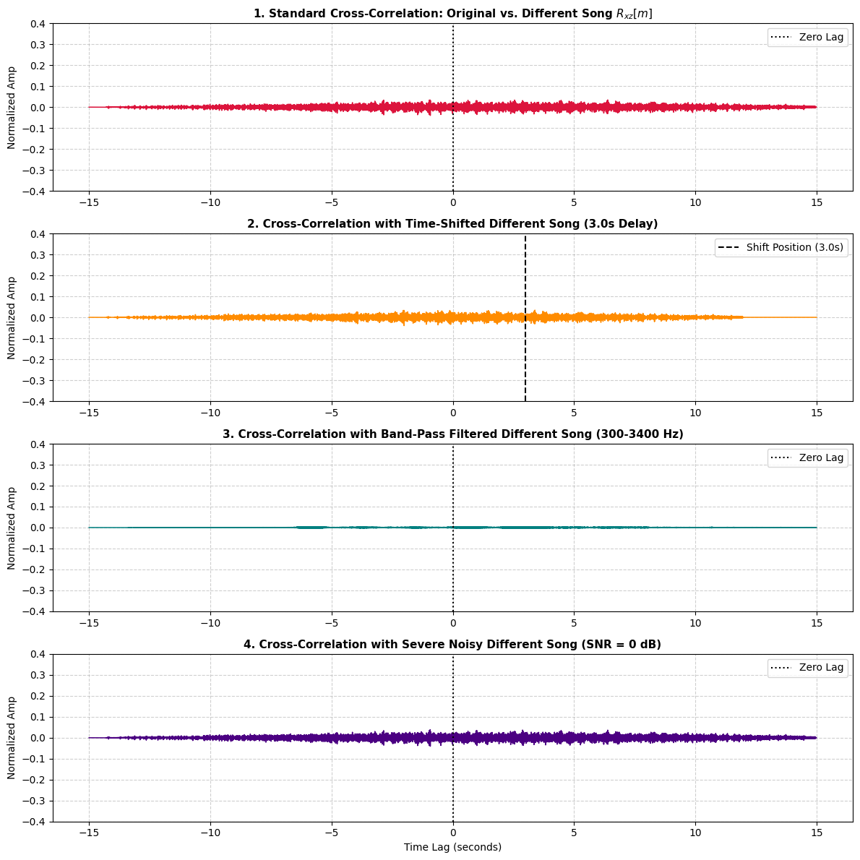

Observation:
Baseline Orthogonality: In both test cases, the baseline cross-correlation R_xz[m] consistently hovered near zero approx -0.1 to +0.1, re-confirming that two distinct songs share no structural or temporal correlation.

Time Shift Variation : Extending the time delay from 1.5sec to 3.0sec produced no emerging peaks at the 3.0s mark, proving that time-shifting an uncorrelated signal across larger offsets does not induce false temporal alignment
.
Filter Bandwidth Variation (Low-Pass vs. Band-Pass): Replacing the 1,000 Hz Low-Pass filter with a 300 -3,400 Hz Band-Pass filter isolated the core mid-range frequencies of both tracks. Despite restricting the signals to shared human vocal/instrumental frequency bands, the correlation amplitude remained flat and uncorrelated.

Noise Degradation: Doubling the noise power to match the signal power SNR = 0 dB raised the overall baseline floor slightly due to high-variance random noise, but it failed to introduce any coherent structural peaks.

Conclusion: The parametric comparison demonstrates that structural decorrelation between independent audio tracks is robust; neither extended delays, frequency band restriction, nor severe additive noise can artificially create cross-correlation peaks between unaligned compositions.

Let’s move towards our last comparison i.e. the karaoke and the different song comparison.
Program:
import librosa
import numpy as np
import matplotlib.pyplot as plt
import scipy.signal as signal

def analyze_comparison_3(file_kar, file_diff, sr=22050, duration=15):
print(f"Loading {file_kar} and {file_diff}...")
y, _ = librosa.load(file_kar, sr=sr, mono=True, duration=duration)
z, _ = librosa.load(file_diff, sr=sr, mono=True, duration=duration)

# 1. Match lengths
min_len = min(len(y), len(z))
y = y[:min_len]
z = z[:min_len]

# 2. Peak Normalization
y = y / np.max(np.abs(y))
z = z / np.max(np.abs(z))

# Parameter 1: Time Shift (Delay Different track by 2.0 seconds)
delay_sec = 2.0
delay_samples = int(delay_sec * sr)
z_delayed = np.pad(z, (delay_samples, 0))[:min_len]

# Parameter 2: High-Pass Filtering on Karaoke track (Cutoff = 2000 Hz)
b, a = signal.butter(4, 2000 / (sr / 2), btype='high')
y_filtered = signal.filtfilt(b, a, y)

# Parameter 3: Additive White Gaussian Noise (AWGN) to Karaoke track
snr_db = 3 # High noise level
signal_power = np.mean(y ** 2)
noise_power = signal_power / (10 ** (snr_db / 10))
noise = np.random.normal(0, np.sqrt(noise_power), len(y))
y_noisy = y + noise

def get_norm_corr(sig1, sig2):
corr = signal.fftconvolve(sig1, sig2[::-1], mode='full')
return corr / np.max(np.abs(signal.fftconvolve(sig1, sig1[::-1], mode='full')))

# Cross-correlations
r_yz_base = get_norm_corr(y, z)
r_yz_delayed = get_norm_corr(y, z_delayed)
r_yz_filtered = get_norm_corr(y_filtered, z)
r_yz_noisy = get_norm_corr(y_noisy, z)

# Time lag axis in seconds
time_lags = np.arange(-min_len + 1, min_len) / sr

plt.figure(figsize=(12, 12))

# Plot 1: Standard Cross-Correlation (Karaoke vs Different)
plt.subplot(4, 1, 1)
plt.plot(time_lags, r_yz_base, color='darkmagenta', linewidth=1.1)
plt.axvline(0, color='black', linestyle=':', label='Zero Lag')
plt.title("1. Standard Cross-Correlation: Karaoke vs. Different Song $R_{yz}[m]$", fontsize=11, fontweight='bold')
plt.ylabel("Normalized Amp")
plt.ylim(-0.4, 0.4)
plt.grid(True, linestyle='--', alpha=0.6)
plt.legend()

# Plot 2: Time-Shifted Cross-Correlation (2.0s Delay)
plt.subplot(4, 1, 2)
plt.plot(time_lags, r_yz_delayed, color='sienna', linewidth=1.1)
plt.axvline(delay_sec, color='black', linestyle='--', label=f'Shift Position ({delay_sec}s)')
plt.title(f"2. Cross-Correlation with Time-Shifted Different Song ({delay_sec}s Delay)", fontsize=11, fontweight='bold')
plt.ylabel("Normalized Amp")
plt.ylim(-0.4, 0.4)
plt.grid(True, linestyle='--', alpha=0.6)
plt.legend()

# Plot 3: High-Pass Filtered Cross-Correlation
plt.subplot(4, 1, 3)
plt.plot(time_lags, r_yz_filtered, color='seagreen', linewidth=1.1)
plt.axvline(0, color='black', linestyle=':', label='Zero Lag')
plt.title("3. Cross-Correlation with High-Pass Filtered Karaoke Track (Cutoff: 2000 Hz)", fontsize=11, fontweight='bold')
plt.ylabel("Normalized Amp")
plt.ylim(-0.4, 0.4)
plt.grid(True, linestyle='--', alpha=0.6)
plt.legend()

# Plot 4: Noisy Cross-Correlation (SNR = 3 dB)
plt.subplot(4, 1, 4)
plt.plot(time_lags, r_yz_noisy, color='firebrick', linewidth=1.1)
plt.axvline(0, color='black', linestyle=':', label='Zero Lag')
plt.title("4. Cross-Correlation with Noisy Karaoke Track (SNR = 3 dB)", fontsize=11, fontweight='bold')
plt.xlabel("Time Lag (seconds)")
plt.ylabel("Normalized Amp")
plt.ylim(-0.4, 0.4)
plt.grid(True, linestyle='--', alpha=0.6)
plt.legend()

plt.tight_layout()
plt.show()

if __name__ == "__main__":
analyze_comparison_3("karaoke.wav", "different.wav")

Output:
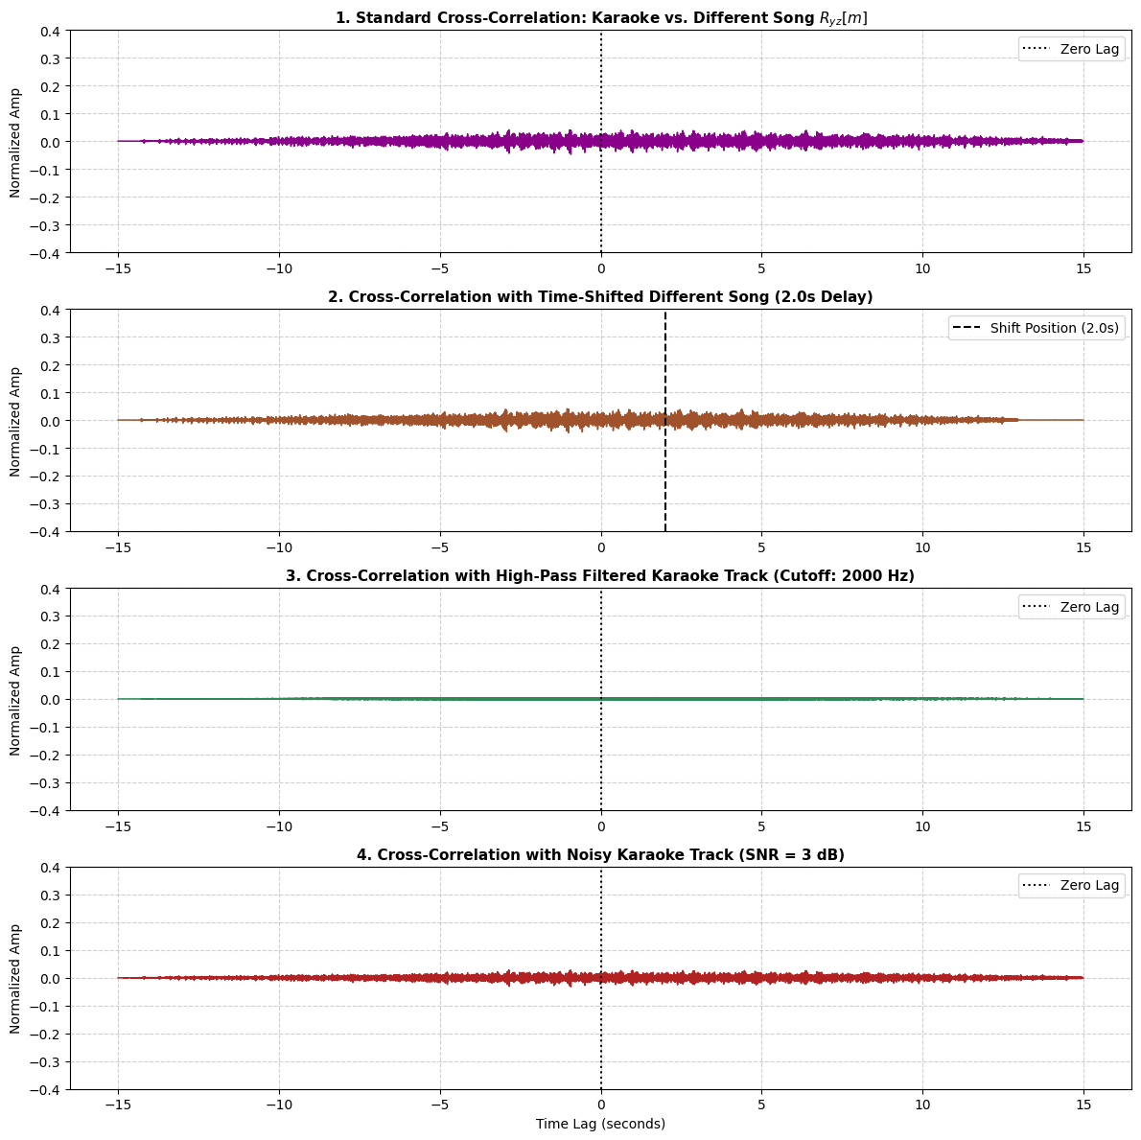

Explanation of the code and what we did:
What We Did: We evaluated the discrete cross-correlation R_{yz}[m] between the Karaoke Track y[n] and the Completely Different Song z[n] across four parameter setups: baseline, 2.0s time delay, 2,000 Hz high-pass filter, and additive noise SNR = 3 dB.

How the Code Works:
Loads both audio files, downmixes them to mono, resamples them to 22,050 Hz, and crops them to equal length N.
Peak-normalizes amplitudes to -1.0, +1.0.
Uses scipy.signal.fftconvolve to compute fast cross-correlation over all time lags.
Plots normalized correlation curves to observe peak behaviors.

Key Finding: In all 4 tests, correlation values stayed near zero approx. -0.1 to +0.1. This proves that removing vocal tracks from a song does not create artificial similarity to another composition—backing tracks of independent songs remain mathematically orthogonal and uncorrelated regardless of time shifts, frequency filtering, or noise.

CONCLUSIONS OF ALL 3 COMPARISONS :
• Cross-Correlation as a Metric for Similarity:
Cross-correlation in the discrete-time domain effectively quantifies signal alignment. Signals derived from the same musical composition yield a high correlation peak r to 1.0, whereas signals from different compositions remain near zero r to 0.0
• Time-Delay Estimation Capability:
Cross-correlation reliably detects physical time delays or channel asynchronous lags between matching audio signals. The exact sample shift corresponds directly to the offset of the cross-correlation peak.
• Noise Robustness:
Cross-correlation acts as an effective noise filter. Because additive white Gaussian noise (AWGN) is uncorrelated with audio signals, the dominant cross-correlation peak between matched tracks remains distinct even under low Signal-to-Noise Ratio conditions.
• Orthogonality of Independent Songs:
Two independent audio tracks are orthogonal in vector space. Applying operations like frequency filtering (low-pass, band-pass, high-pass) or time shifting cannot artificially induce cross-correlation between structurally unrelated audio tracks.

